PRACTICAL-1
1.Problem scopes
- Check attendance
- Course selection
- View results
- Check timetable
- Contact faculty
- Download study material
- Attendance tracking
- Apply for leave
- Add/Edit student information
- Event & Announcement feed
- Give feedback
- View fee payment status
2.User roles

Student
- Login
- View attendance
- View marks/results
- View timetable
- Register for courses
- Apply for leave
- Download study material
- View fee payment status
- Give faculty feedback
- Add/Edit personal information
- Contact faculty

Faculty
- Login
- Upload attendance
- Upload marks
- Upload study material
- Upload test schedules
- Approve leave requests
- Interact with students

Administrator
- Login
- Manage students
- Manage faculty
- Upload notices

3.Key modules

Module | Description
Authentication | User Login and Logout
Dashboard | Displays important information after login
Attendance | View and manage attendance
Results | View and upload marks
Timetable | View class schedules
Course Selection | Register for courses
Study Material | Upload and download notes
Leave Management | Apply and approve leave
Feedback | Submit feedback
Notice Board | View announcements
Profile | Manage personal information

4.Navigation flow
[ 🔑 UNIVERSAL LOGIN ]
│
▼ (Role Verification Check)
│
├──► [ 🧑‍🎓 Student Role ] ──────► [ 🏠 STUDENT DASHBOARD ]
│ │
│ ├──► [ 📅 Attendance Tracker ] ──► (View Attendance %)
│ ├──► [ 📑 Course Registration ] ──► (Select & Submit Courses)
│ ├──► [ ⏳ Timetable Viewer ] ───► (View Daily Schedule)
│ ├──► [ 📊 Results Portal ] ─────► (View Marks & GPAs)
│ ├──► [ 📥 Resource Center ] ────► (Download Study Notes)
│ ├──► [ 📨 Leave Management ] ───► (Submit Leave Request)
│ └──► [ 💬 Feedback Portal ] ────► (Submit Evaluation)
│
├──► [ 🧑‍🏫 Faculty Role ] ──────► [ 🏠 FACULTY DASHBOARD ]
│ │
│ ├──► [ 📋 Attendance Portal ] ──► (Select Class ──► Mark Roll Call)
│ ├──► [ 📈 Gradebook Manager ] ──► (Select Course ──► Upload Marks)
│ ├──► [ 📤 Repository Sync ] ───► (Upload Course Materials)
│ ├──► [ 🗓️ Exam Scheduler ] ────► (Set & Publish Test Dates)
│ └──► [ 📥 Inbox Requests ] ────► (Review Leaves ──► [Approve/Reject])
│
└──► [ ⚙️ Admin Role ] ────────► [ 🏠 ADMINISTRATOR PANEL ]
│
├──► [ 👥 User Directory ] ─────► (Add / Edit Student & Faculty Profiles)
└──► [ 📢 Announcement Hub ] ──► (Draft Notice ──► Broadcast to Feeds)

5. Visual Sitemap
[ 🌐 LANDING & LOGIN PAGE ]
│ └── [ 🎛️ MAIN DASHBOARD (Role-Based View) ]

│ ├── [ 📅 ATTENDANCE HUB ]

│ ├── 🟩 Student: View Live Attendance Summary

│ └── 🟦 Faculty: Daily Roll Call Input Sheets

│ ├── [ 🎓 ACADEMICS SUITE ]

│ ├── 📑 Course Selection (Student Registration)

│ ├── ⏳ Timetable (Class Schedules)

│ └── 📊 Results Portal (Student: View Grades | Faculty: Upload Marks)

│ ├── [ 📂 DIGITAL LIBRARY ]

│ └── 📥 Study Material (Student: Download | Faculty: Upload Data)

│ ├── [ 📨 REQUESTS & FEEDBACK ]

│ ├── 📇 Leave Management (Student: Apply Form | Faculty: Action Box)

│ └── 💬 Faculty Feedback System (Anonymous Student Forms)

│ └── [ 🛠️ CONTROL CENTER (Admin Only) ]

├── 👥 User Management (Add/Edit Profiles) └── 📢 Notice Board Manager (Broadcast Engine)

6. Wireframes
6. Modern Wireframes (High-Scannability Component Layouts)
🖥️ UI Component 1: Universal Login Screen
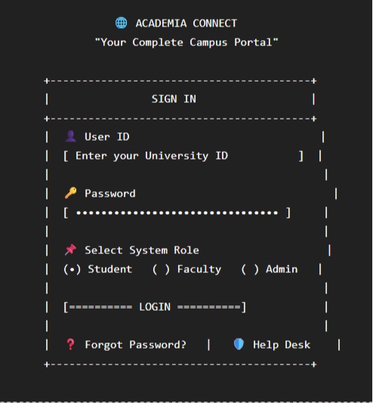

🧑‍🎓 UI Component 2: Student Dashboard Interface
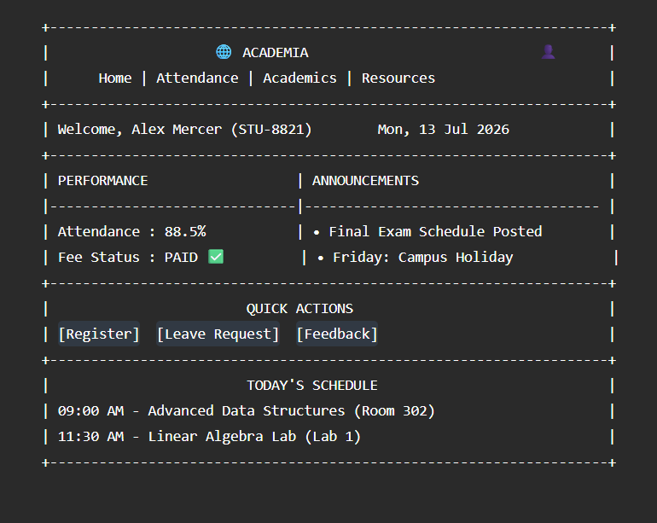

🧑‍🏫 UI Component 3: Faculty Dashboard Interface
